This is a suggested script that teachers can use for each point on the trail below, along with the accompanying PowerPoint images. Please ensure you read the introduction to the trail before embarking on it.
This trail on ‘African Lives in Newcastle’ has been designed in collaboration with African Lives in Northern England to stir curiosity and a sense of pride in Newcastle’s rich and diverse past. It will take you to places that African and Caribbean people lived and visited. These people all contributed to our region and their lives are embedded in the fabric of our region.
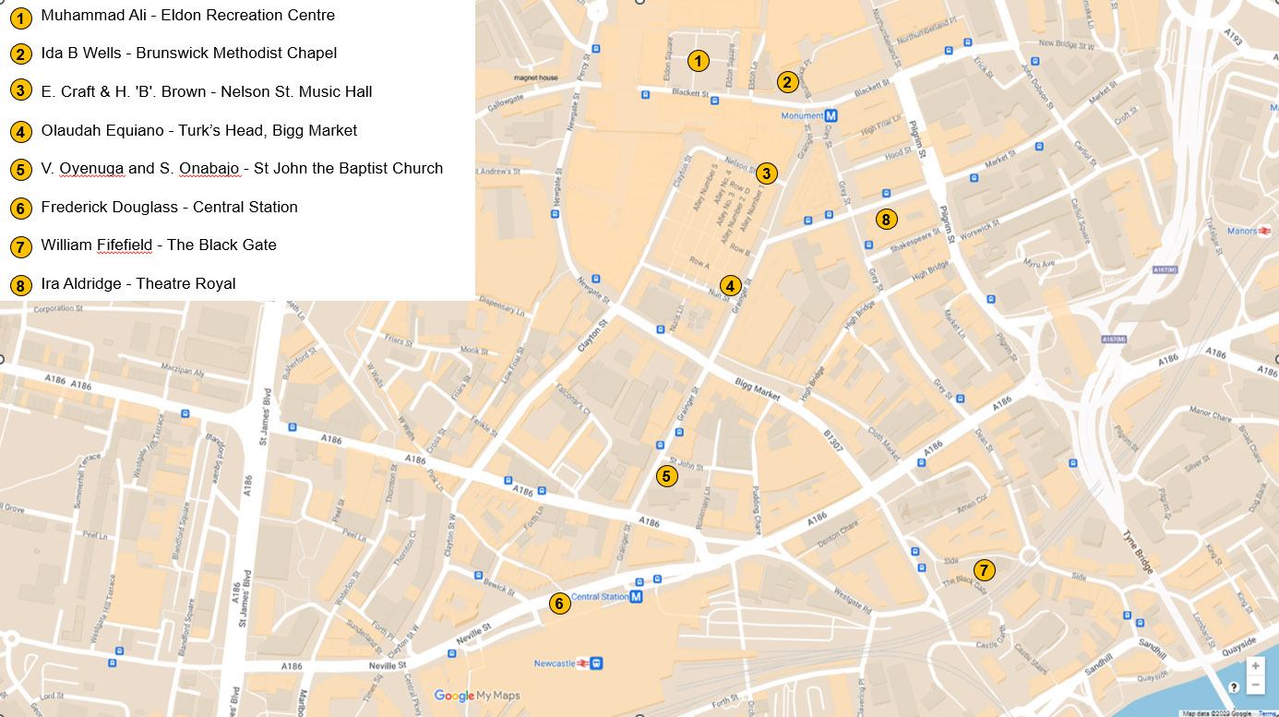

In the classroom, pupils can use the PPT and the StoryMap to revisit the people and buildings on the trail. For each person and building the StoryMap contains a wealth of additional information and images – to help stir pupils’ curiosity and a sense of pride in Newcastle’s rich and diverse past.

Content Warning – this trail, StoryMap and associated resources cover some topics that may be sensitive and could be upsetting. These include, but are not limited to:
- Point 2 - Ida B Wells at Brunswick Methodist Chapel and references to ‘lynching’
- Point 4 - Olaudah Equiano and references to enslavement and the murder of 131 enslaved Africans in the Zong massacre.​

Point 1: Muhammad Ali (1942-2016)
Location to stand whilst reading: https://what3words.com/grain.snake.pulse

In 1977 Muhammad Ali, an American professional boxer, activist, entertainer, and philanthropist, visited Newcastle. (Show PPT Slide image titled: Muhammad Ali)

Muhammad Ali, celebrated as ‘The Greatest’ for his boxing success (he won 56 of his 61 matches), had been invited to Newcastle to raise funds for a local boy’s club by Johnny Walker, a local painter and boxing enthusiast.

He astounded all by accepting the invitation in 1977 and raising money for the National Boys Clubs, particularly those in Tyne and Wear. Ali impressed all with his warmth and humour -even eating a Geordie stottie. (Show PPT Slide image titled: Muhammad Ali easting a stottie)

Highlights of his visit included an interview in Eldon Recreation centre, broadcasted live to television viewers and a bus tour in South Shields. He was surrounded by thousands on his open-air bus tour of South Shields. (Show PPT Slide image titled: Muhammad Ali on an open top bus tour)

Ali and Veronica, his wife, had their marriage blessed at Al Azhar Mosque in South Shields. There were 300 guests and a crowd of 7,000 well-wishers. In 1961, he had converted to Islam and in 1966 refused to be drafted into the military, citing his religious beliefs and ethical opposition to the Vietnam war, ‘a war against brown people’.

Muhammad Ali said of his visit to Newcastle and South Shields in his interview at Eldon Recreation Centre, in Eldon Square shopping centre: ‘I’ve never been so honoured – not in America itself by Government officials and authority.’

Ali summed up his philosophy and the reason he continued boxing, during his interview in Eldon Recreation Centre:

‘There are a lot of things I want to promote, as far as human rights, as far as people uniting, coming together, loving, and respecting one another, helping bring peace to the world. There is a lot I can do with the title. The longer I hold it, the more I do. That’s why I stay in it’
Point 2: Ida B Wells at Brunswick Methodist Chapel
Location to stand whilst reading: https://what3words.com/grand.reader.radio
Ida B. Wells (1862-1931) was a journalist and a campaigner in the United States for the rights of African Americans, all women and all workers. She visited Newcastle in 1893 and 1894 to win financial and moral support for her anti-lynching campaign. (Lynching is when of a group of people kill someone for an alleged offence, without a legal trial, especially by hanging.) (Show PPT Slide image titled: Ida B Wells)

She co-founded the Alpha Suffrage Club in Chicago, USA, to further voting rights for all women, most particularly for black women. She openly challenged the marginalisation of black women in the 1913 National Women’s Suffrage Parade in Washington DC, USA.

Her campaign began when the black owners of the successful Peoples’ Grocery in Memphis, Tennessee, USA were lynched (murdered by a white mob) in 1892.

When she spoke at the Brunswick Methodist Chapel in Newcastle and elsewhere, she shocked the audiences with graphic stories of the mutilations and deaths of black men from lynching. She used the evidence from the investigations she had written about in her book Southern Horrors (1892). (Show PPT Slide image titled: Southern Horrors book cover)

Ida B. Wells was often attacked and isolated for her radical approach. However, she had the support of the abolitionist Frederick Douglass who publicly praised her courage. (Find out more about Frederick at Point 6)

She was posthumously awarded the Pulitzer Prize in 2020 for: ‘her outstanding and courageous reporting on the horrific and vicious violence against [4,084] African Americans during the era of lynching’.

Despite campaigning by many, the law making lynching a federal hate crime was only passed in 2022.

Point 3: E Craft & H. 'B'. Brown at Music Hall, Nelson Street
Location to stand whilst reading: https://what3words.com/occurs.margin.manual
The Music Hall in Nelson Street, built by Grainger and opened in 1838, was a popular venue. Between 1840 and 1860, it hosted innumerable speakers against the enslavement of African-Americans. These included Ellen Craft and Henry 'Box' Brown, who lectured solely at this working class and non-denominational venue. Other African-American campaigners against enslavement who lectured here were Moses Roper, William Wells Brown and Frederick Douglass.

Ellen Craft (1829-1891) with her husband, William, escaped from enslavement in Georgia, USA. Ellen who was of light complexion, disguised herself as a white gentleman travelling for medical treatment, with William as her ‘slave’. (Show PPT Slide image titled: Ellen Craft)

She used a sling to avoid being asked to sign her name. Ellen could not write as enslaved Africans were not allowed to learn to read or write.

They escaped to England in 1851 to avoid recapture, speaking twice at the Music Hall in March 1851. Their brave and creative method of escape, risking detection and death attracted, crowds to their lectures.

Henry 'Box' Brown (1815-1897) asked a carpenter he trusted to make him a wooden box to escape enslavement in Richmond, USA, after his wife and three children were sold. On 23 March 1849, his friends posted him in this box from Richmond to freedom in Philadelphia, USA. (Show PPT Slide image titled: Henry 'Box' Brown)

He then went to Liverpool in 1850, to avoid recapture, and travelled across northern England. He performed on four occasions, in October 1852, at Newcastle's Nelson Street Music Hall.

He used his own story and his new name Henry 'Box' Brown to create an ‘anti-slavery’ performance, getting in and out of a box and displaying a panorama of visual images of the horrific treatment of the enslaved.

Point 4: Olaudah Equiano (1745-1797)
Location to stand whilst reading: https://what3words.com/cliff.teach.bolts

Olaudah Equiano was a leading advocate for the abolition of the trade of enslaved Africans and a supporter of parliamentary reform. (Show PPT Slide image titled: Olaudah Equiano)

He stayed at the Turks Head, near Bigg Market, Newcastle in 1792 and promoted his book against enslavement' The Interesting Narrative of the Life of Olaudah Equiano or Gustavus Vassa, the African.'

He sold his book at Robert Denton’s bookshop opposite the Turk’s Head pub, near Bigg Market and at other bookshops in Newcastle. (Show PPT Slide image titled: Bigg Market, Newcastle-upon-Tyne, 1820)

The Turks Head had a few rooms for travellers, and it is likely that Olaudah Equiano stayed there and spoke at its meeting room, named the 'Theatre in the Bigg Market'.

He stayed in Newcastle for 3 weeks. He expressed appreciation for the sales of his book and the reception which he received in Newcastle and the North East both in the Chronicle on 6 October 1792 and in the Newcastle Courant on 8 October 1792, offering: ‘warmest thanks… for your fellow-feeling for the Africans and their cause.’

Before journeying to Durham and Stockton Olaudah Equiano visited St. Anthony's Colliery, near Newcastle. He went 90 fathoms down inside the colliery and in his book expressed amazement at being under the River Tyne!.

Equiano’s numerous speaking tours promoted his book and greatly increased public support for the abolition of the trade in enslaved Africans. He alerted Granville Sharpe (a white abolitionist) to the Zong massacre. This was where 131 enslaved Africans were thrown overboard while still alive.

The 'slave' trade was formally abolished in the United Kingdom in 1807, ten years after his death.

Point 5: V. Oyenuga and S. Onabajo at St John’s Baptist Church
Location to stand whilst reading: https://what3words.com/curve.paid.bride

St John’s Church built around 1130, is one of the oldest Anglican churches in Newcastle.

On April 11th 1950 the marriage of Victor Adenuga Oyenuga, aged 29 and Sabinah Babafunke Onabajo, aged 25, was celebrated at St John the Baptist Church, with around 4,000 people attending. (Show PPT Slide image titled: Victor and Sabinah on their wedding day)

This marriage was reported in the Newcastle Chronicle as ‘A Nigerian Romance to City Wedding’ and celebrated in Newcastle and Lagos, Nigeria as ‘the wedding of the year’.

Victor Oyenuga and Sabinah Onabajo both from the Ijebu region of Nigeria. They had made a traditional marriage in 1942 before Victor left for England to undertake an agricultural degree in Newcastle in 1945.

Sabinah, a pupil-teacher, saved for her passage and joined him in 1949, enrolling for nurse training at Princess Mary Maternity Home.

Victor had been ‘shocked and embarrassed that the churches at Newcastle did not welcome ‘blacks.’ However, following an introduction by a church-going lecturer, Victor was welcomed by the Vicar of St John the Baptist Church. (Show PPT Slide image titled: Wedding party outside St John’s Church)

This wedding was significant not only because it was a black couple but because it was a black couple known and loved in their respective spheres – the university and hospital. This led to its coverage in local and other newspapers. There were massive crowds inside and outside the church, four diverse ministers and the service lasted 4 hours.

Several months later the baptism of their first child Victor Adetokumbo took place in St John the Baptist Church.
Point 6: Frederick Douglass at Central Station
Location to stand whilst reading: https://what3words.com/gear.laws.clots

Frederick Douglass (1818-1895) was an American abolitionist, speaker, writer, and statesman. He travelled widely in Britain, speaking in Newcastle in 1846 and 1860. His speeches and his autobiographies greatly increased support for the abolition of enslavement. Douglass was a celebrity in his own lifetime and actively supported women’s suffrage. Frederick was enslaved himself and escaped in 1838. (Show PPT Slide image titled: Frederick Douglass)

Newcastle Central Station was officially opened by Queen Victoria on the 29th of August 1850. It consolidated the train routes that had been expanding since the 1840’s. These routes were essential for the rapid movement and frequent lectures of abolitionists like Frederick Douglass.

Frederick Douglass first travelled to the North East in 1846, lecturing against enslavement and promoting his first book, Narrative of the Life of Frederick Douglass, an American Slave, 1845. He spoke at the Salem Chapel, Hood Street, on August 3rd and 13th 1846 at meetings of the Newcastle Antislavery Society. On the first occasion, the 1200-capacity church was packed nearly to overflowing. (Show PPT Slide image titled: Salem Chapel, Hood Street, Newcastle)

Douglass was so popular in the North East that, according to The Newcastle Chronicle, a special train was hired for the crowds from Sunderland, North and South Shields to attend his evening lecture in Gateshead.

Frederick Douglass was warmly welcomed by abolitionists in Darlington, Gateshead, and Newcastle. He reinvigorated the numerous anti-slavery societies in the North East and his freedom was bought by Henry and Anna Richardson, Newcastle Quakers.

He spoke at Nelson Street Music Hall in February 1860, during his second visit to Newcastle. He spoke of his joy that ‘Newcastle had a heart that could feel for three million of oppressed slaves in the United States of America’.

To date Frederick Douglass is the only person of African descent who has been recognised by Newcastle City with a plaque, installed at the Richardson’s home in Summerhill Grove in 2018. The Frederick Douglass Centre, a stunning Newcastle University auditorium and lecture theatre was opened in 2018 by Kenneth B Morris Jr, the great, great, great grandson of Frederick Douglass.
Point 7: William Fifefield at The Black Gate
Location to stand whilst reading: https://what3words.com/legs.shine.sock

William Fifefield (1769-1834), from St Kitts, in the West Indies, settled in Newcastle in 1794. He and his family lived at Bailey Gate near the Black Gate.

The Black Gate was the fortified gateway added to the castle keep between 1247 and 1250 on the orders of King Henry III. From the 17th century, houses and shops were built in and around the Castle Keep and the Black Gate.

He joined the Newcastle Volunteers, a civilian ‘regiment’ of the army, as a drummer. He owned a ‘Comfortable’ – a small, covered ferryboat, which ferried people up and down the Tyne River using oars and the tide. William operated from a pub called The Dun Cow, which was on Grindon Chare, just to the east of the Tyne Bridge. (Show PPT Slide image titled: ‘The Mayor’s Barge on the Tyne’ by W. Carmichael, 1828 The two smaller boats were known as ‘comfortables’)

He later lived at Tuthill Stairs, a chare (narrow alleyway) between the castle and the quayside. He married Margaret Winthrup (the daughter of Walter Winthrup, a farmer from Longframlington, Northumberland), at St Mary’s Church, Gateshead. (Show PPT Slide image titled: Tuthill Stairs, Newcastle upon Tyne, 1885)

His son William Thomas and his daughter Margaret Grace were christened in St Nicholas Cathedral, Newcastle.

His oldest son, William Thomas Fifefield worked as a barber, and set up his business first in Cloth Market, and later at Groat Market.

William (senior) was buried in St John the Baptist Church, Grainger Street, Newcastle. He was described in his obituary as ‘very generally known and respected in his station’.

Point 8: Ira Aldridge at The Theatre Royal
Location to stand whilst reading: https://what3words.com/keen.thigh.gears

The Theatre Royal was built by Richard Grainger within six months in 1837. Ira Aldridge (1807-67), performed at the Theatre Royal, Newcastle several times between 1837 and 1857, as well as in Alnwick, Berwick, and Sunderland.

He is believed to be the first black Shakespearean actor and is particularly famous for his performances as Othello. Popular throughout Europe, he received awards from the Prussian and Russian states. A Russian critic wrote: ‘After Aldridge it is impossible to see Othello performed by a white actor, even Garrick himself’. (Show PPT Slide image titled: Ira Aldridge as Othello)

Ira Aldridge moved to England from the USA in 1824. He first performed, age 14, in New York with the first African-American theatre company. He was a major attraction at the Theatre Royal in Newcastle. In the late 20th Century, a room at the theatre carried his name. He was so popular in the North East that additional dates were needed for his appearances in Berwick.

He was less popular in London where he performed in five plays, including Othello in 1825. Only after his success in Europe, was he fully accepted on the London stage.

Aldridge was subject to racist views, which were openly expressed by the media and critics. He experienced racism in cities like London and Liverpool with a strong pro-‘slavery’ lobby. The Athenaeum magazine on the 13 April 1833 wrote: 'Impossible that Mr Aldridge should fully comprehend the meaning and force of even the word he utters.'

Racism didn’t stop Aldridge performing and he didn’t just play ‘black’ roles. He was praised for his Macbeth and King Lear in Europe and the provinces. Aldridge was one of the first actors to speak from the stage on the closing night on topical issues, sharing his anti- ‘slavery’ views. (Show PPT Slide image titled: Ira Aldridge as King Lear)

The Lancaster Herald, 1832 wrote: ‘We feel as though he were the advocate, the representative of a nation, pleading its cause from the heart, and we think of him and that nation, when the dazzling light […] of theatrical machinery, have passed away, - when we are alone to think, to reflect.’

