Episode 10: The Cosy Corner
In this episode you might come across some new words. Here are some we thought were interesting:
Embellishments – a decoration added to something to make it seem more attractive or interesting
Ornate – grand and impressive in appearance
Oriel windows – a type of window that sticks out from a building, but which doesn’t touch the ground
Charlie Chaplin – an English comic actor, filmmaker, and composer who rose to fame in the era of Silent Movies
Silent Movie – a movie that has no recorded sound. All films were silent from the mid-1890s to the late 1920s.
DIY store – also known as hardware stores, they sell building materials, tools, paint, and garden items – like B&Q today.
Hatter – a person who makes and sells hats
Spinster – a woman who has never been married; used especially when talking about an old or middle-aged woman
Straw boater – a hard straw hat with a flat top and brim which is often worn for certain social occasions in the summer
Cladding – a covering of tiles, wooden boards, or other material that is fixed to the outside of a building

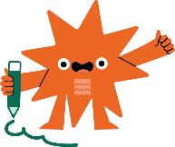
As you are listening:
Jot down things you find interesting…

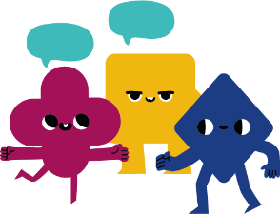
What types of shops are mentioned in this episode?

Discuss your answers as a class.
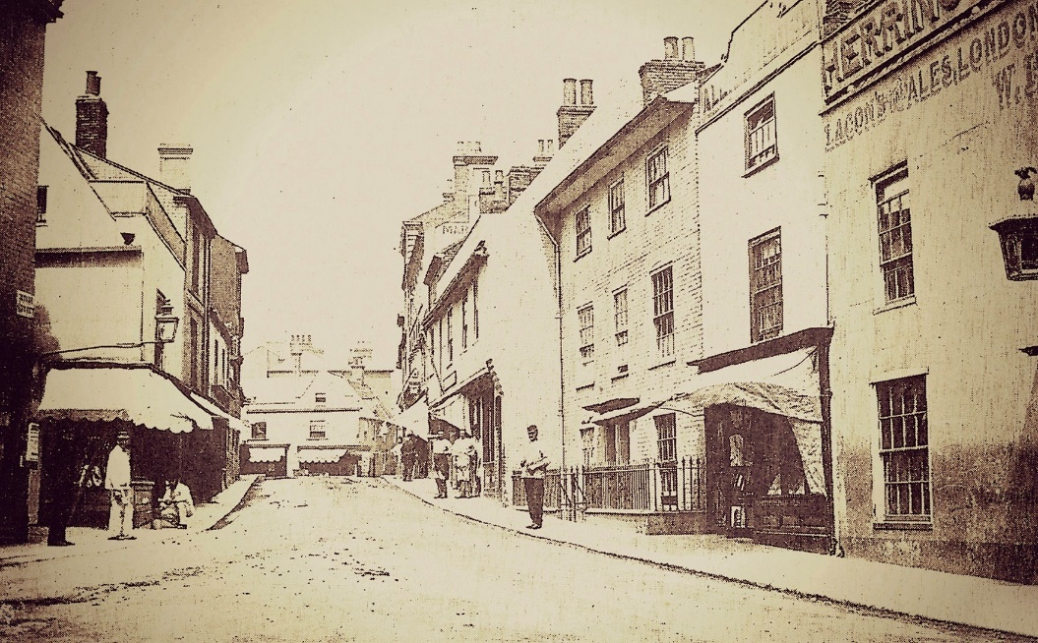  © Jack Rose Collection | 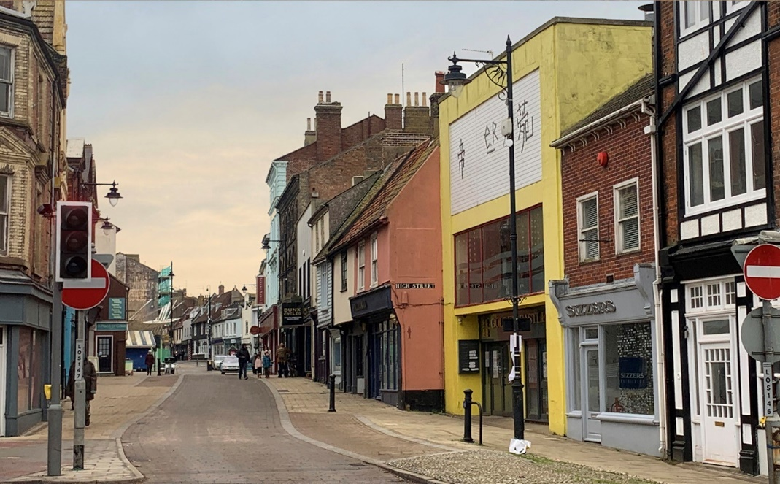  © Dean Parkin
Lowestoft's High Street then and now

As you listen write down how the buildings and the street view has changed and what has stayed the same.

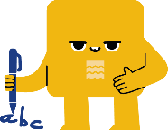
Look at the two photos of the same view, then and now — what changes do you notice in these scenes?

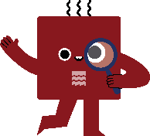

Write a poem about what used to be there but isn't now including:
1. three lines about the changes in the street
2. three lines about how you have changed and what you used to do and what you do now.

Example:
I Used To / But Now
There used to be a cinema but now there's a restaurant.
That shop used to sell hats now it's full of bikes.
There used be twelves chimneys but now there's three.
I used to play piano but now I sing.
I used to have a skateboard now I have a scooter.
I used to want to be a seagull but now I want to be a goalie

